HNC CANOPEN CONFIGURATION

Contents

**1.Download and install driver** 2

**2. Wiring** 2

2.1. Connect CAN 3

2.2. Connect CN1 3

**3. Configuration** 4

3.1. Reset encoder 5

3.2. Display all parameter 5

3.3. Set max speed during torque control 6

3.4. set encoder to maximum resolution 7

3.5. Enable CanOpen 9

3.6. Config filter 9

3.7. enable Force stop 10

3.8. disable prohibit for testing 11

3.9. Save paramters to Servo Driver 11

3.10. Restart servo 12

# **1.Download and install driver**

<http://www.hncelectric.com/en_download.aspx?cid=&category_id=0&page=2>

there is a document too

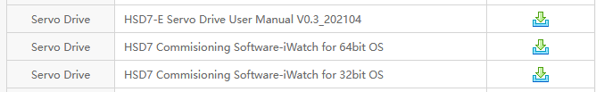

# **2. Wiring**

LAN Connector

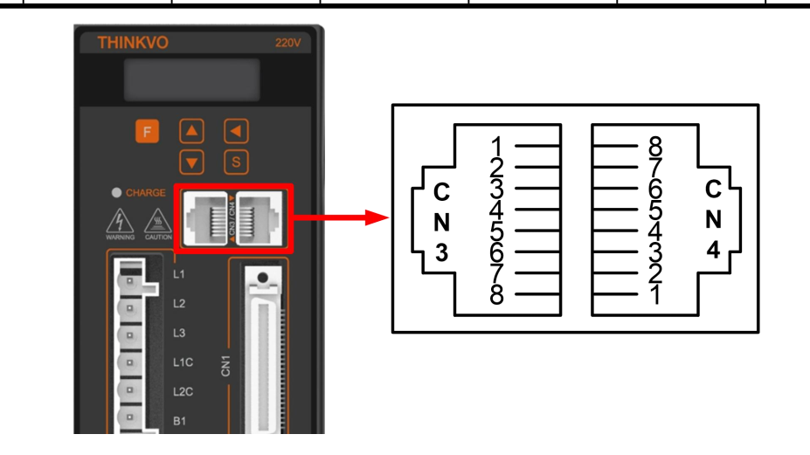

DB25 connector

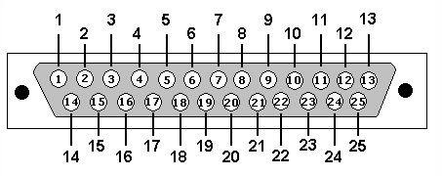

CN1 Connector

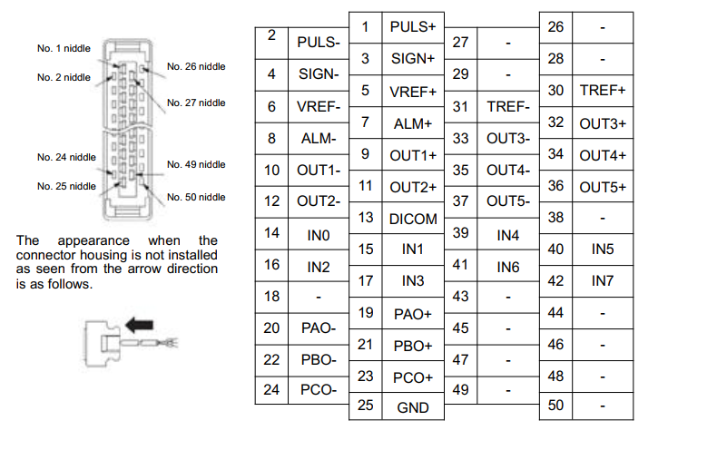

## 2.1. Connect CAN

Use LAN cable (20NM use CN3, 30 NM use CN4, can test which port can use)

|  |  |  |
| --- | --- | --- |
| **CN3 or CN4** | **Description** | **DB25** |
| 1 | CAN H | 18 |
| 2 | CAN L | 6 |
| 3 | GND | 14 |

## 2.2. Connect CN1

Use at least 7 wires cable

|  |  |  |
| --- | --- | --- |
| CN1 | **Description** | DB25 |
| 13 | 24V | 1 |
| 14 | Servo On | 2 |
| 15 | Force stop (E-Stop) | 15 |
| 16 | P-OT | 8 |
| 17 | N-OT | 8 |
| 23 | Z+ | 13 |
| 24 | Z- | 25 |

# **3. Configuration**

* Use mini usb to USB connect servo driver to PC

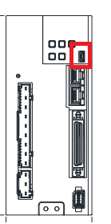

* Open iwatch -> choose serial port (not port 1) -> seach -> choose device -> connect

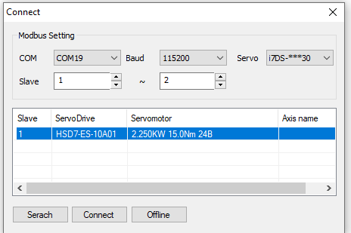

* Click C/E to choose English

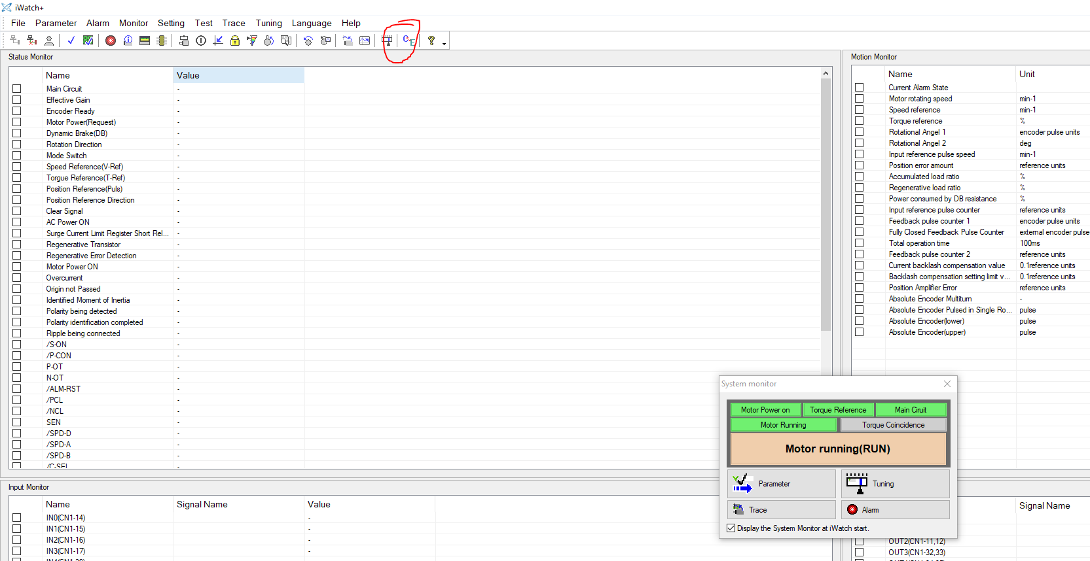

## 3.1. Reset encoder

If driver has alarm A.810 reset encoder.

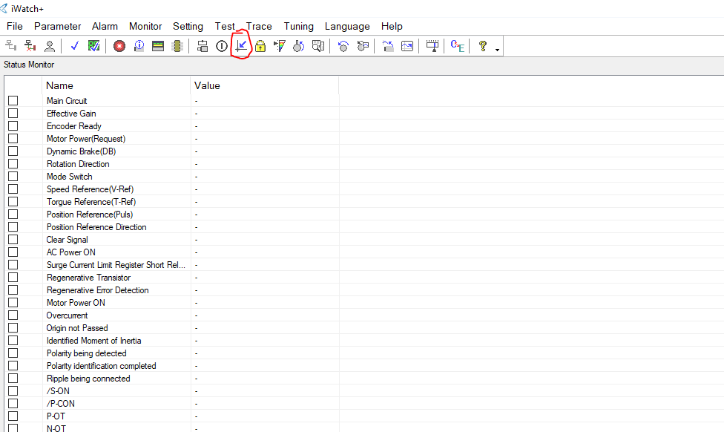

* Click “excecute” 🡺 power off driver 🡺 power on again.

## 3.2. Display all parameter

PN00B-> set “operator parameter display selection” too “display all parameters”

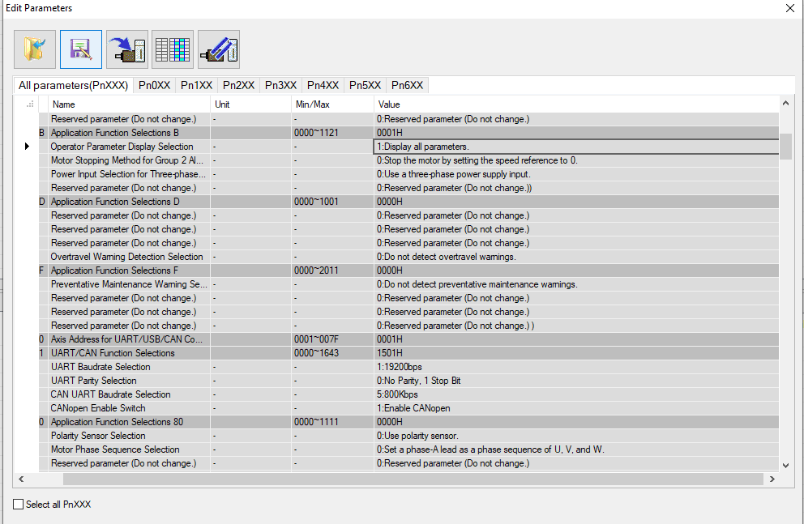

## 3.3. Set max speed during torque control

PN407 (here I set 150 rpm, you can choose from 120-200, depend on you :D)

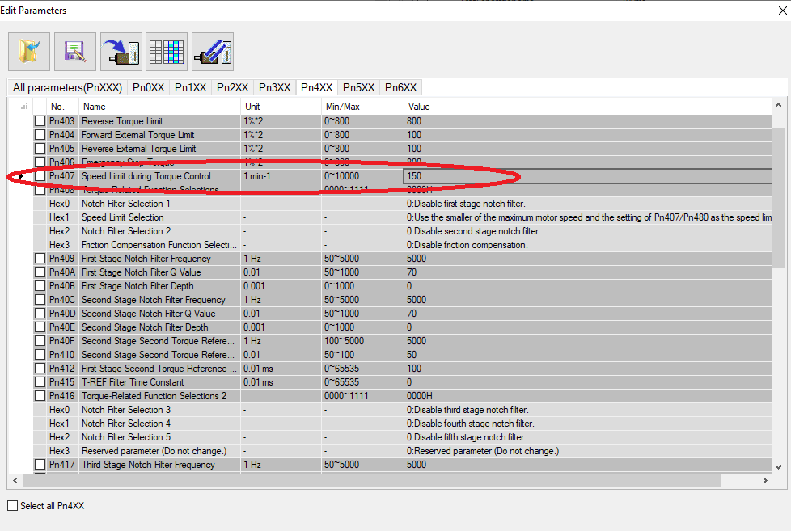

## 3.4. set encoder to maximum resolution

PN20E and PN210

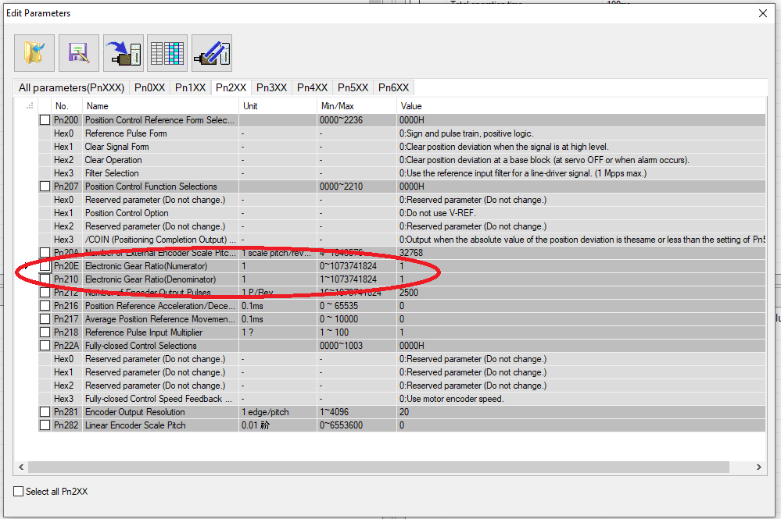

Config encoder as single turn

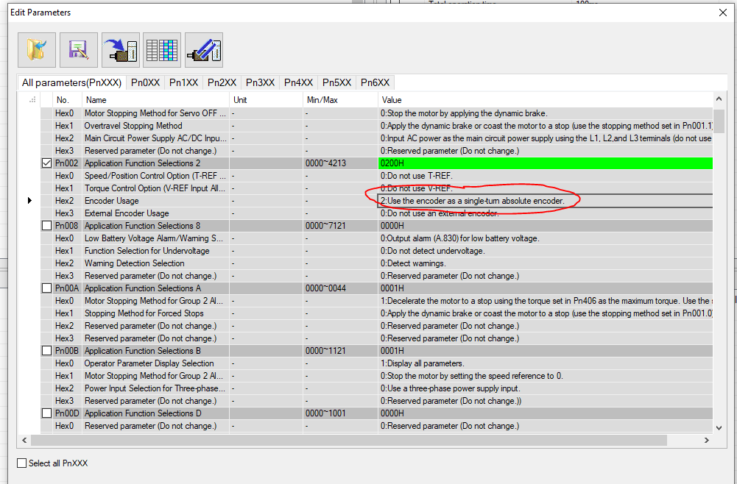

## 3.5. Enable CanOpen

PN011: Hex 2 change from 500kbps to 1000kbps, hex3 enable can open

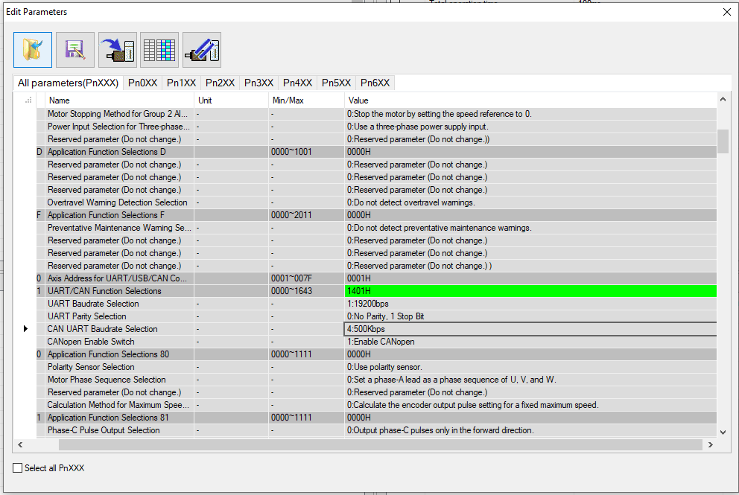

## 3.6. Config filter

Enable filter and cutoff freq to 200hz

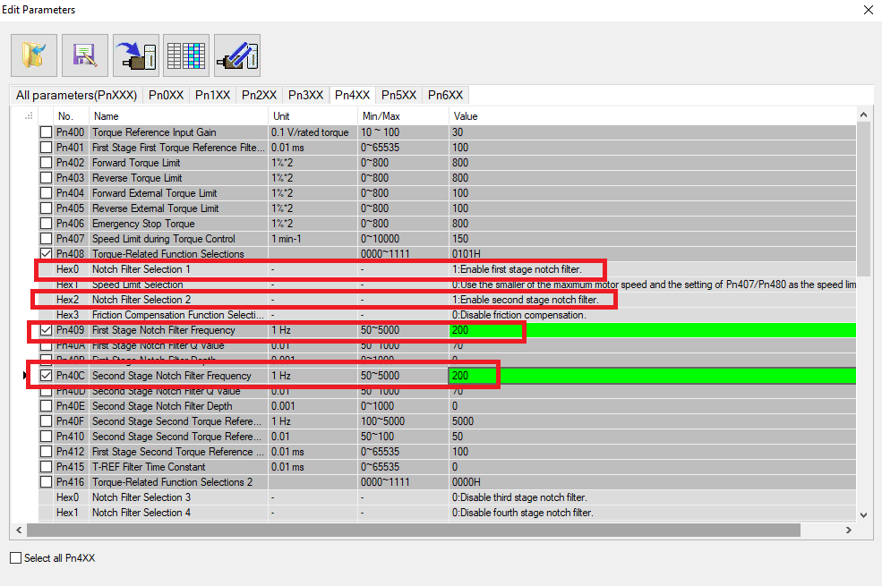

## 3.7. enable Force stop

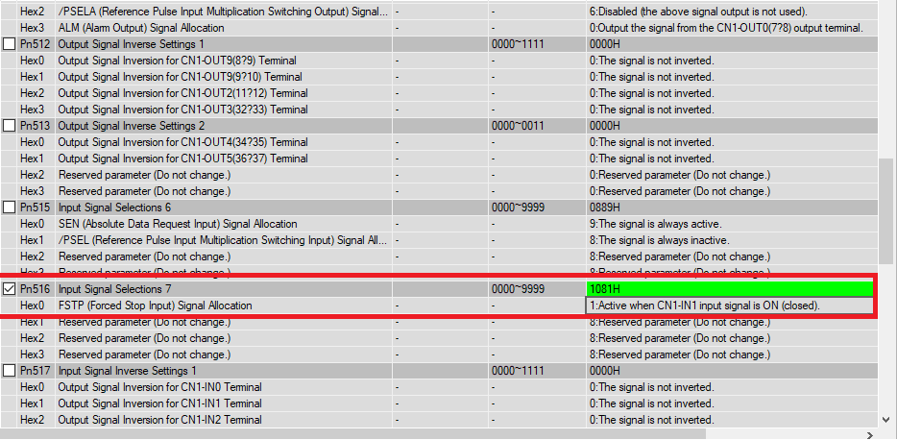

## 3.8. disable prohibit

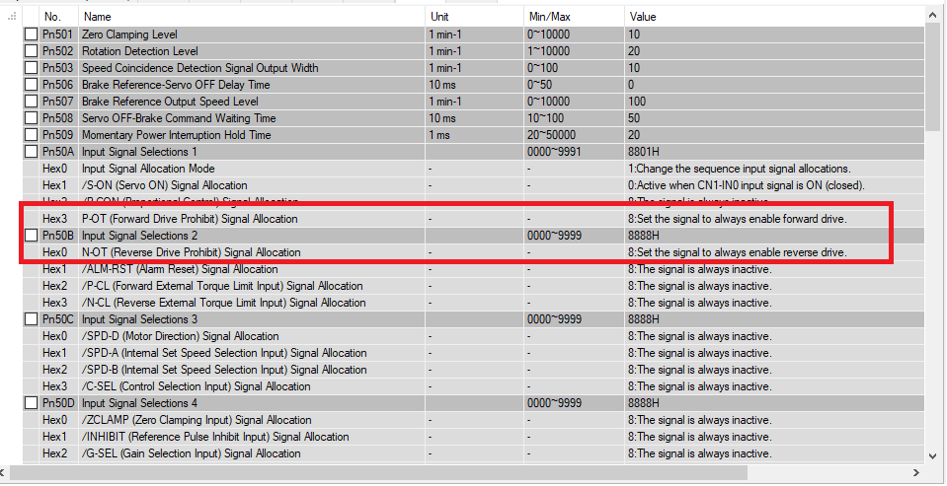

## 3.9. Save paramters to Servo Driver

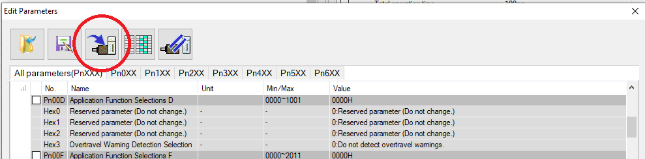

## 3.10. Restart servo